
Sukkur IBA University
Department of Computer Science
Applied Physics Lab, Spring-2024

Lab-09: VOLTAGE-CURRENT CHARACTERISTICS OF PN JUNCTION DIODE
Instructor: Engr. Asif Ali

Note: Submit this lab hand-out in the next lab with attached solved activities and exercises

Submission Profile
Name: Submission date:
Enrolment ID: Receiving authority name and signature:
Comments:
________________________________________________________________________________
Instructor Signature
Lab Learning Objectives:

Upon successful completion of this experiment, students will be able,
- To understand the voltage-current characteristics of PN junction diode by using NI-Elvis Kit
- Multisim (simulation)

Lab Hardware and Software Required:
EQUIPMENT / COMPONENTS
- NI- ELVIS Kit
- Different values resistors
- Different PN Junction diode
- Connecting wires

Background Theory:

A diode is a device formed from a junction of n-type and p-type semiconductor materials. The lead connected to the p-type material is called the anode and the lead connected to the n-type material is the cathode. In general, a solid line on the diode, as shown in fig-1-1, marks the cathode of a diode.
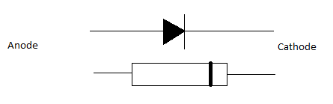
Fig 1-1

When the positive terminal of diode is connected with positive terminal of battery, this condition allows the current to flow the p-n junction, referred as Forward bias, but when the negative terminal of diode is connected with positive terminal of battery, this condition prevents the current to flow across the p-n junction, referred as Reversed bias. These two possible conditions are shown in figure 1-2.

Lab Examples:

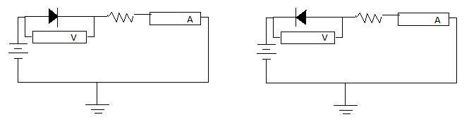
Figure 1-2 (a) Forward Bias Figure 1-2 (b) Reverse Bias

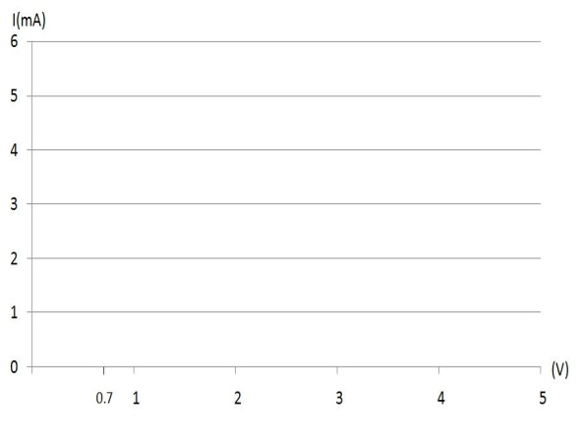

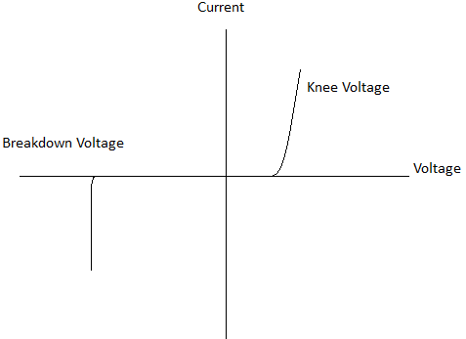

PROCUDURE:

  - Make the circuit as shown in figure 1-2(a), using the silicon diode (IN 4001) and 1- KΩ resistor on the Breadboard.
  - Now switch on the power supply and carefully turn the voltage control clock wise whilst watching the ammeter.
  - Set the values of the voltage up to 10V and observe the values of current. Plot these values on the graph paper. The resulting graph should show the little current passes until the voltage has risen to 0.7V (for silicon), but the current rises rapidly with further increase in voltage.
  - Change the resistor and diode values, repeat all previous steps and fill the observation table.
  - Finally plot the V-I characteristics of diode on graph paper (excel chart).
  - For reverse biasing in fig 1-2 (b), when apply normal voltage then approximately zero current will flow.
OBSERVATION TABLE-01:
S. No | Resistor(Ω) | Voltage (V) | Forward bias (A)  Current in fig 1-2 (a)
1. | 1000 Ω | 0.1 | 0.00000018838 A
2. | 1000 Ω | 0.4 | 0.000036207 A
3. | 1000 Ω | 0.7 | 0.00035867 A
4. | 1000 Ω | 1 | 0.000500378 A
5. | 1000 Ω | 1.5 | 0.00096627 A
6. | 1000 Ω | 2 | 0.001445 A
7. | 1000 Ω | 3 | 0.0024019 A
8. | 1000 Ω | 4.5 | 0.003864 A
9. | 1000 Ω | 7 | 0.006367 A
10. | 1000 Ω | 10 | 0.009347 A
.OBSERVATION TABLE-02:
S. No | Resistor(Ω) | Voltage (V) | Reverse bias (A)  Current in fig 1-2 (b)
1. | 1000 Ω | 0.1 | 0.0000000027457 A
2. | 1000 Ω | 0.4 | 0.000000003237 A
3. | 1000 Ω | 0.7 | 0.0000000032689 A
4. | 1000 Ω | 1 | 0.0000000032987 A
5. | 1000 Ω | 1.5 | 0.0000000033488 A
6. | 1000 Ω | 2 | 0.000000003399 A
7. | 1000 Ω | 3 | 0.0000000034993 A
8. | 1000 Ω | 4.5 | 0.000000003649 A
9. | 1000 Ω | 7 | 0.0000000038997 A
10. | 1000 Ω | 10 | 0.0000000041999 A

Graph of Forward Bias:

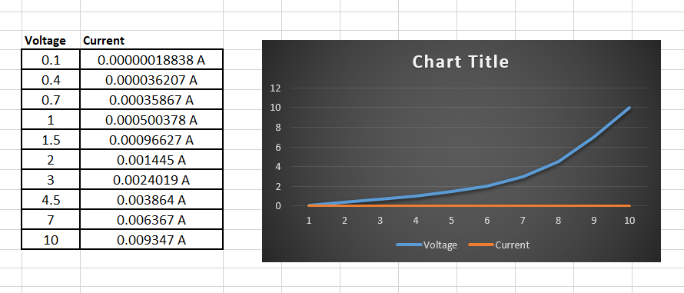

Lab Activity:

REVIEW QUESTIONS:
1. What do you mean by term biasing?
Biasing involves applying a steady voltage or current to electronic components, like transistors, to ensure they operate in a desired range, allowing them to function properly and produce the desired output signals.
2. What is turn on voltage for silicon and germanium at room temperature?
The turn-on voltage for silicon diodes is typically around 0.7 volts at room temperature, while for germanium diodes, it's around 0.3 volts.
3. What is barrier potential?
Barrier potential is like a hurdle that blocks the flow of electricity across a junction in a semiconductor. It takes a certain amount of voltage to get past this hurdle and allow current to flow through.
___________________________________________________________________________

4. What is the depletion region?
The depletion region is a zone at the junction where there are no free electrons or holes, creating a barrier to the flow of electric current.

5. Why Diode shows non-linear characteristics
A diode shows non-linear characteristics because its current doesn't change in a straight line with voltage. Instead, the current increases exponentially with voltage due to the diode's built-in structure, which allows it to conduct current more readily in one direction than the other.

Lab Exercise:
Perform experiment of different circuits of diode by using Multisim software.
Readings:
Circuit in Forward Bias:
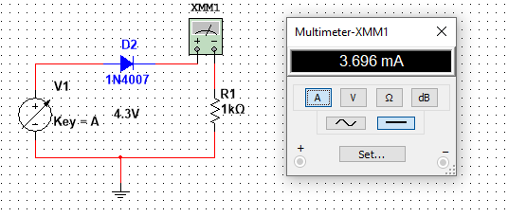

Circuit in Reverse Bias:

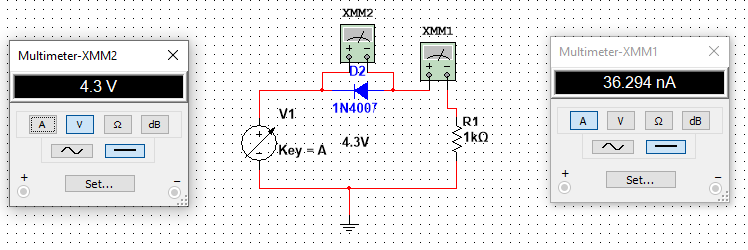

Table-03
S. No | Resistor(Ω) | Voltage (V) | Forward bias (A) | Voltage | Reverse Bias (A)
1. | 1000 Ω | 0.1 | 0.0000001883 A | 0.1 | 0.0000000027457 A
2. | 1000 Ω | 0.4 | 0.000036207 A | 0.4 | 0.000000003237 A
3. | 1000 Ω | 0.7 | 0.00035867 A | 0.7 | 0.0000000032689 A
4. | 1000 Ω | 1 | 0.000500378 A | 1 | 0.0000000032987 A
5. | 1000 Ω | 1.5 | 0.00096627 A | 1.5 | 0.0000000033488 A
6. | 1000 Ω | 2 | 0.001445 A | 2 | 0.000000003399 A
7. | 1000 Ω | 3 | 0.0024019 A | 3 | 0.0000000034993 A
8. | 1000 Ω | 4.5 | 0.003864 A | 4.5 | 0.000000003649 A
9. | 1000 Ω | 7 | 0.006367 A | 7 | 0.0000000038997 A
10. | 1000 Ω | 10 | 0.009347 A | 10 | 0.0000000041999 A

